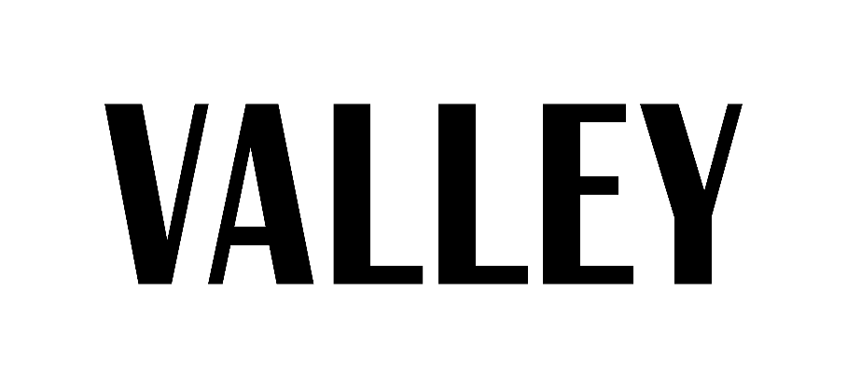

Business Division: Public Relations
Spring 2018

Description of Position:
As a member of the Public Relations Division, your primary role will be to promote Valley Magazine throughout the semester. This team works to produce numerous giveaway events, content to share for social media, and further branding of the magazine. One example is taking part in an event called Valley Week that goes on after each production of the magazine. Those with outgoing personalities do best in this position, as you must feel comfortable reaching out to other students and talking to people around campus. You will be expected to schedule time outside of meetings during the semester, to participate in promotional events. It is crucial that you attend weekly meetings, execute the tasks asked of you, and remain dedicated to Valley Magazine throughout the semester.

Name: ___________________
PSU Email: __________________
Gmail: ___________________
***If chosen, it will be required you create a Gmail account ***
Major: ________________
Semester Standing: ________________

*Please attach a copy of your resume.
*All applications need to be emailed to Public Relations Directors, Alexa Turkovich alexaturkovich@gmail.com and Caroline Sorrentino carsorrentinoo@gmail.com, and Business Director Sandra Carrillo at sandra.carrillo@gmail.com by Sunday, November 19th at 7 p.m.

Also, please be aware that an interview is very likely, as we want to get to know who you are and answer any specific questions you may have before joining staff!

1. Have you been on Valley before? If yes, what division were you on and what was your most memorable contribution to Valley? If no, how did you hear about Valley and what made you want to join?

2. The five sections of Valley are Beauty & Health, Entertainment, Campus Culture, Self Improvement and Fashion. Think of a promo item (something small/affordable that we could give out) that ties into one of these themes, and explain why you’ve picked it. Be creative.

3. During Valley Week, PR is in charge of coming up with events, which will both promote the magazine and get people excited about the magazine’s release. In depth, come up with a hypothetical event that could happen in the HUB for Valley Week.

4. Why do you want to be a member of the Public Relations Division of Valley Magazine?

5. What other activities do you plan to be involved in next semester?

6. Is there anything else you’d like us to know about you?

