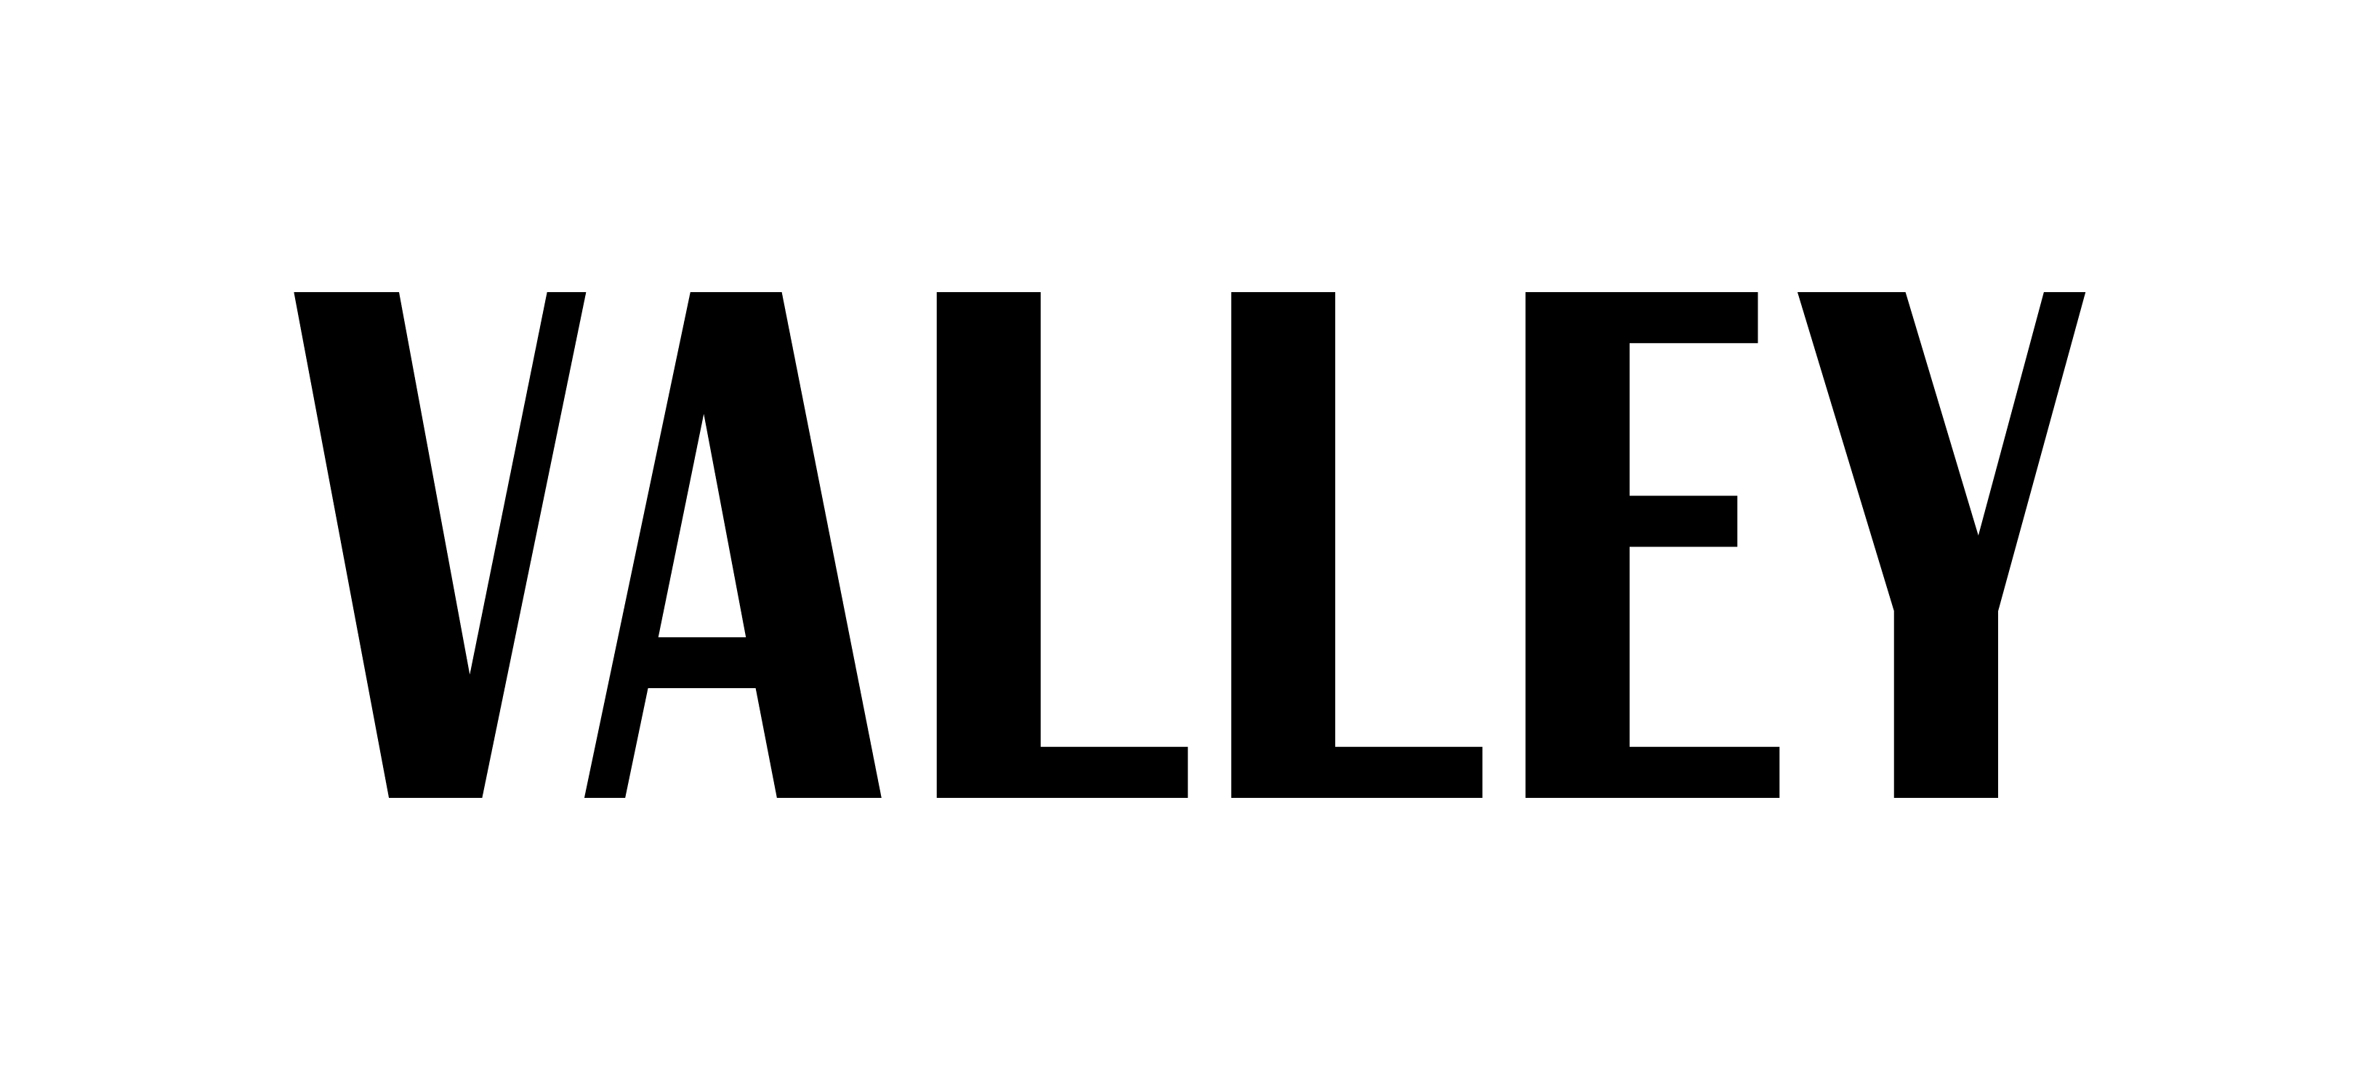

Business Division: Social Media
Spring 2018

Description of Position:
The Social Media Division of Valley works with all of our social media platforms such as Twitter, Facebook, Instagram and more. We are a growing media platform with our online digital website and promote the magazine in the best way possible with our new look!

Name: _______________________
PSU Email: ____________________
Gmail: ________________________
***If chosen, we need to you create a Gmail account***
Major: ____________________
Semester Standing: _________

*Please attach a copy of your resume
*All applications need to be emailed to the Social Media Director Natalia Mujica nataliakmujica@gmail.com and Business Director Sandra Carrillo at sandra.carrillo@gmail.com by Sunday, November 19th at 7 p.m.

- What social media platforms do you use/are most familiar with?

- Please copy links to your various, most used social media platforms (particularly Facebook, Twitter, and Instagram).

- What do you think VALLEY’s social media has been doing well?

- What do you think VALLEY could work on and what suggestions/ideas do you have to better VALLEY’s social media presence?

- What things would you like to see VALLEY post and include on social media? (Series, tutorials, videos, photo ideas, types of tweets, etc.)

- Do you have any other skills/previous experience that might benefit the social media team? (i.e. previous SM internship, graphic design, editing, video making, YouTube channels, photography, etc.)

