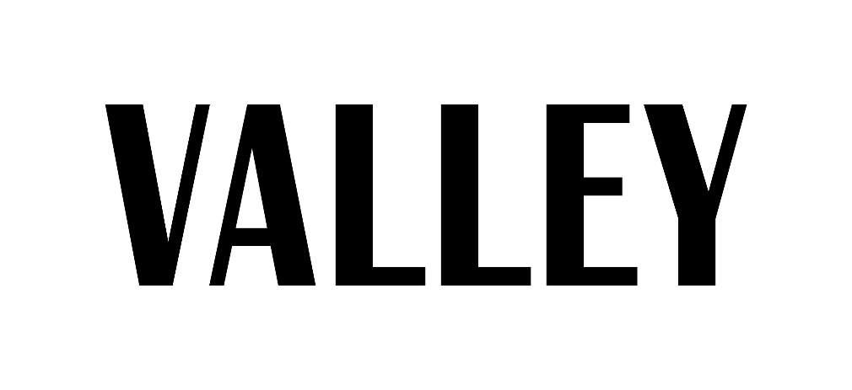

Spring 2018 Writer Application

Writer auditions will be held on December 4 at 7 p.m. in 105 Willard Building.

We will give you a prompt to be written on the spot. Bring a pen or pencil, notebook paper and a copy of this application, including everything described below. Auditions will include a short info-session; feel free to bring questions.

Read carefully! There are two pages!

If you cannot attend the auditions and would still like to apply, please contact Caroline Rosini at carolinerosini18@gmail.com for information about make-ups. You may also contact this email address with any questions.

Thanks for your interest in writing for Valley Magazine! Please know that if selected as a member of our staff, you’ll be responsible for weekly web articles (www.valleymagazinepsu.com). After a semester writing for web, you will be qualified to write for our print magazine.

We expect that each article you write while on staff includes credible sources, quotes and is written in strict AP Style and in Valley voice – we’ll go over what this means. We do not tolerate missed deadlines, plagiarism, unexcused absences or sub-par effort. Valley is an organization and a publication; we hope that you take this commitment seriously. That being said, we do have a lot of fun – don’t worry!

What you need to attach and bring to auditions:
- Copy of your resume
- One or two writing samples (You do not need to have quotes/sources in these pieces. We are looking at your writing style and ability)
- 10 article ideas for the Spring 2018 issue – be creative.
- Five web ideas, which means one for each section: Beauty & Health, Campus Culture, Entertainment, Self Improvement and Fashion.

You will be notified if you made it to the interview round within a few days of your audition. Interviews will be held Dec. 5 – 8.

Answer (type, please!) the following questions in a few sentences and bring your responses to auditions. Have fun with it!

Name:
Email:
PSU ID (xyz1234):
Phone #:
Year:
Major/Minor:

Which section would you most like to write for and why? (Again, the sections are: Beauty & Health, Campus Culture, Entertainment, Self Improvement and Fashion. (You are not limited to any section if you are selected to join staff—you can write for any of them. We just want to get to know your style and interests.)

What’s your favorite article from our last edition (Fall 2017) and why?

Please pick a web article from our website (give us the title) and critique it. What do you applaud? What would you have done differently?

Please list past writing experience, including relevant school courses:

Why do you think you’re a good fit for our staff?

Please explain why you think it is important to have a life & style publication at Penn State.

How would your friends describe you?

What’s your dream job? (If it’s not to be EIC of magazine, that’s a-OK! Our staff is fairly diverse in terms of career aspirations. If you write well, you write well!) How will working for Valley help shape your career goals?

