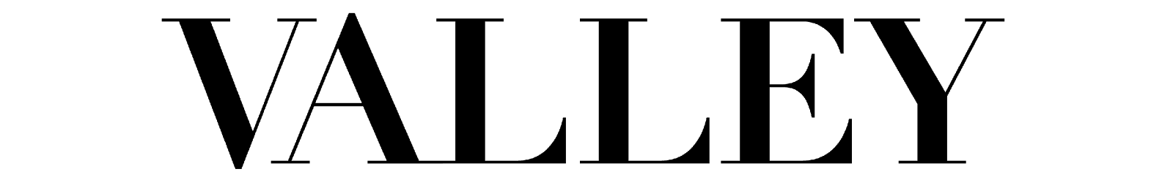
Spring 2017 Photographer Application

Please send this application, your resume and a portfolio/sample of your past photography work to Vanessa Feng at vanessafeng1993@gmail.com and Kayleigh Barber at kayleighjbarber@gmail.com by Sunday, December 21 by 5 p.m.

Portfolio guidelines: Please send 10-20 images that you would consider to be “life and style”(fashion/beauty/culture). Portraits are preferred, but please show a variety of work that you feel fits the VALLEY aesthetic.

Name:
Class Standing:
Major:
Email:
Phone:

1. Please describe your prior photography experience.

2. When do you plan to graduate?

3. What other organizations are you currently involved with?

4. What kind of camera do you own?

5. What photography (or other relevant courses), if any, have you taken so far at Penn State?

7. Why are you interested in joining Valley?

8. Which, if any, magazines do you read/look at? Do you have a favorite?

9. What photographers influence your work?

10. Meeting deadlines is an imperative part of this position. Meeting deadlines can be demanding, especially in the midst of schoolwork and other activities. How do you plan to manage your time so that you can meet your deadlines?

