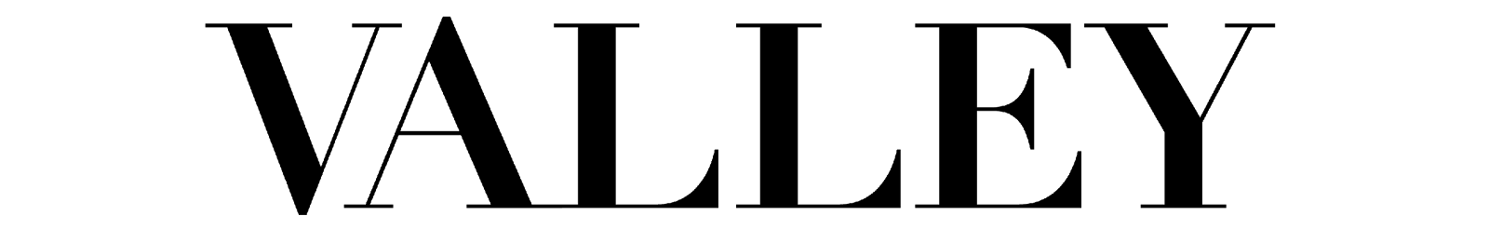
Fall 2017 Video Staff Application

Please send this application, your resume and a portfolio/sample of your past videography work to Zoey Gottlieb at gottlieb.zoey@gmail.com and Kayleigh Barber at kayleighjbarber@gmail.com by Sunday, April 16 by 5 p.m.

This is a new position starting in the fall. The video staff will work with both the editorial staff to create web content relating to fashion/health/culture and with business staff to help promote Valley on social media.

Portfolio guidelines: Please send 2-3 video samples (new or old projects) that you would consider to be “life and style” (fashion/beauty/culture). 1-2 minute long videos are preferred, but please show a variety of work that you feel fits the VALLEY aesthetic.

Name:
Class Standing:
Major:
Email:
Phone:

1. Please describe your prior videography experience.

2. When do you plan to graduate?

3. What other organizations are you currently involved with?

4. What kind of camera do you own?

5. What photography/videography (or other relevant courses), if any, have you taken so far at Penn State?

7. Why are you interested in joining Valley?

8. Which, if any, magazines do you read/look at? Which do you visit online? Do you have a favorite?

9. Who do you view as an influence/inspiration to your work?

10. Meeting deadlines is an imperative part of this position. Meeting deadlines can be demanding, especially in the midst of schoolwork and other activities. How do you plan to manage your time so that you can meet your deadlines?

